Farah Programming Exercise 13: Output Screenshots
Name: Anthony Farah
Date: July 15, 2026
Repository:
This document contains screenshots and output from Programming Exercise 13.
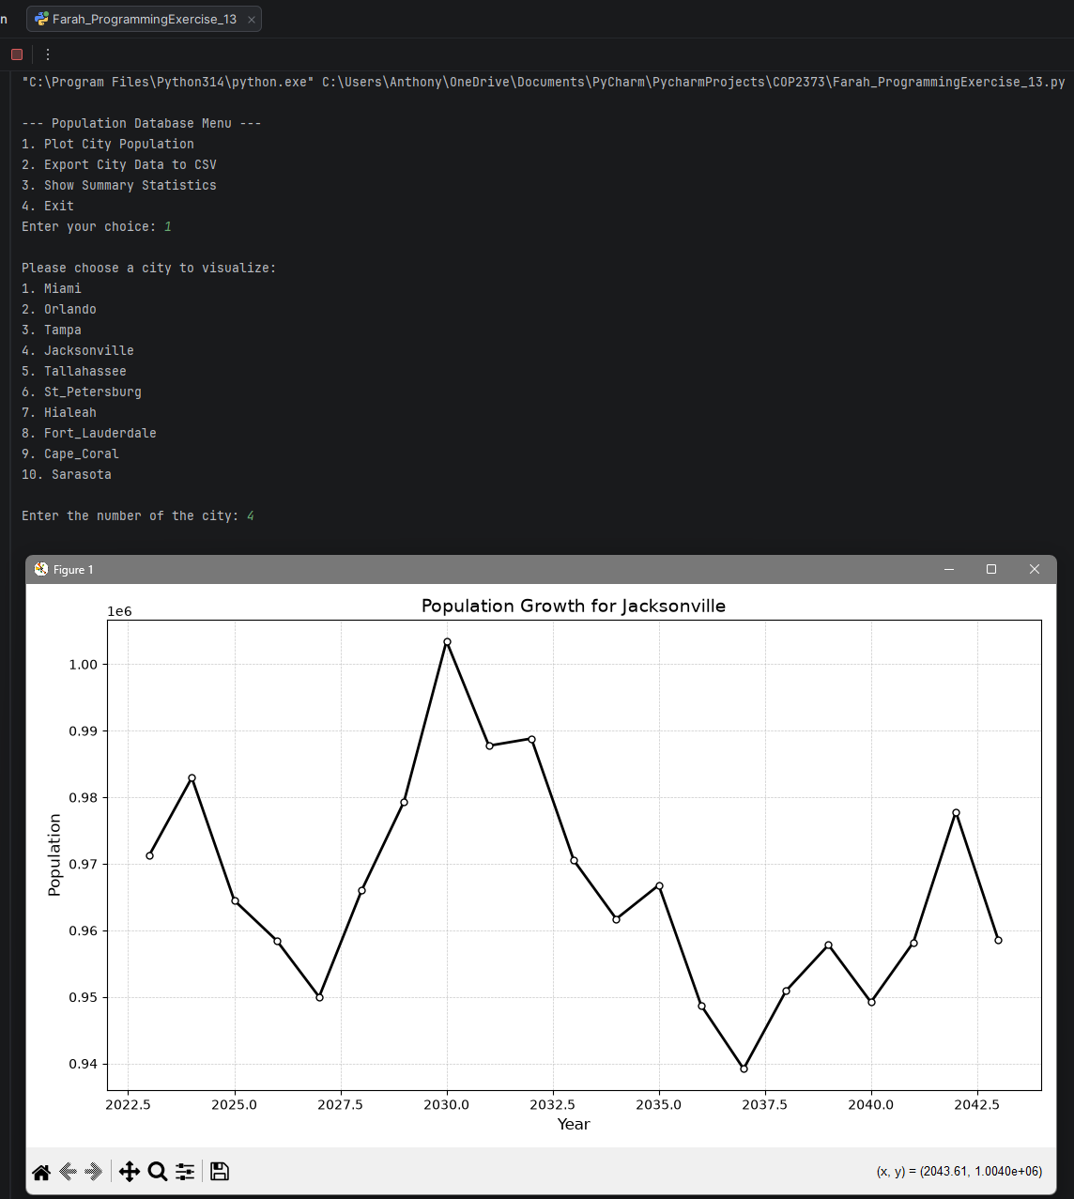
This screenshot shows the program successfully launching and displaying the Population Database Menu. The user selects the “Plot City Population” option and chooses Jacksonville from the list of available Florida cities, confirming that the menu system, input handling, and database retrieval are functioning correctly.

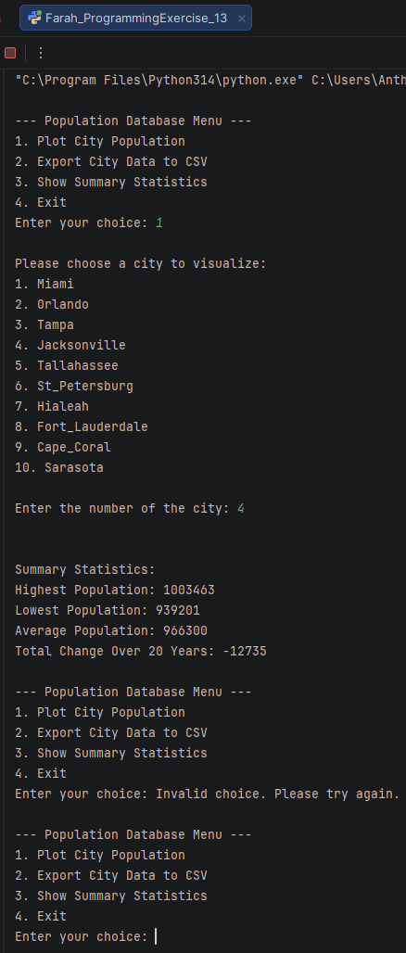
This screenshot displays the academic-style matplotlib graph generated for Jacksonville’s population growth over 20 years. The plot demonstrates that the simulation, database queries, and visualization functions are working as intended, producing a clear and readable representation of population trends.
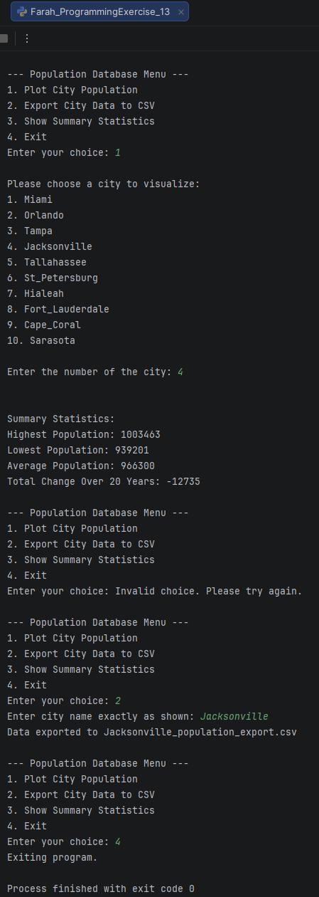
This screenshot shows the summary statistics calculated for Jacksonville, including highest, lowest, average population, and total change over the 20-year simulation. It also confirms successful CSV export functionality, indicating that the program’s data analysis and file output features are operating correctly.

